NEW YORK-AMERICAN CHORAL DIRECTORS ASSOCIATION
11th ANNUAL ELEMENTARY CHILDREN’S HONOR CHOIR
COME SING WITH THE FINEST!

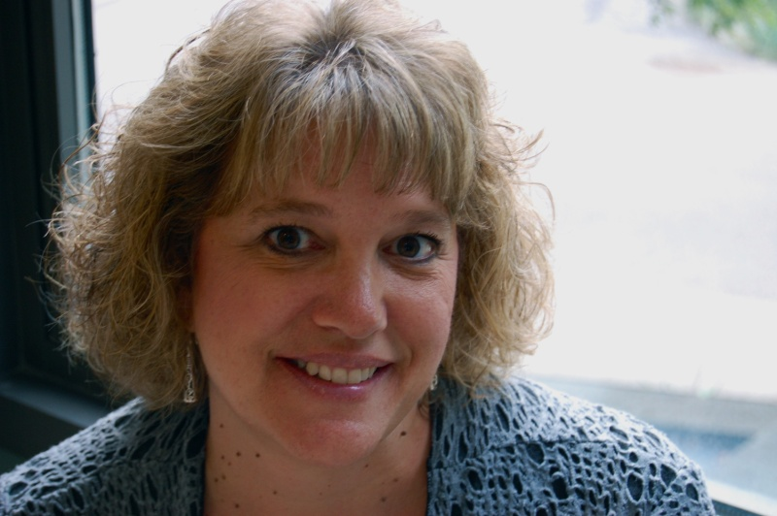 | NY-ACDA is proud to have acclaimed children’s choir director  Mrs. Robyn Lana  as this year’s guest conductor.

ACDA and NYSSMA members can nominate current 4th, 5th, and 6th graders to be part of this ensemble of 100+ singers from around the state!

For further information please check our website at http://www.nyacda.org
or contact Elizabeth Woodhouse at ewoodhouseacda@gmail.com

